**Math 120  
8.3 Geometric Sequences and Series**

# **Objectives:**

1. Find the common ratio of a geometric sequence.
2. Write terms of a geometric sequence.
3. Use the formula for the general term of a geometric sequence.
4. Use the formula for the sum of the first n terms of a geometric sequence.
5. Use the formula for the sum of an infinite geometric series.

# **Topic #1: Geometric Sequences**

A sequence is a string of numbers with some pattern or rule to get from one term to the next. Consider the sequence:

$3, 6, 12, 24, …$

The pattern suggests to “multiply by 2” to get to the next term. Using the pattern, here are the first $10$ terms:

$$3, 6, 12, 24, 48, 96, 198, 396, 792, 1584$$

Since the change from one term to the next is constant (here, the *relative* change is $2$ times more from one term to the next), the sequence is **__________________**

The constant __________________ change is called the common ratio, $r$ and the graph of the first $10$ terms in the sequence shows the pattern is “exponential”. Notice the “base” is the common ratio.

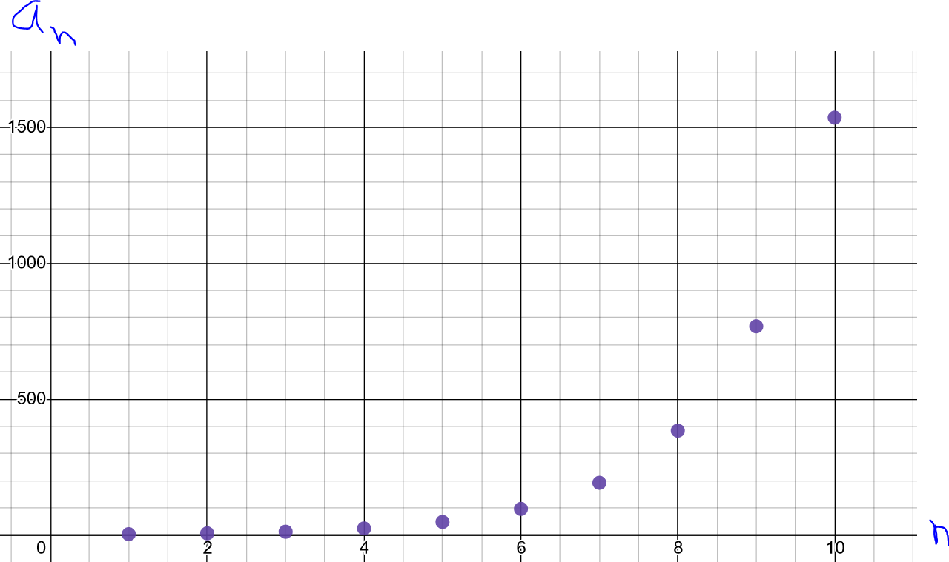

In this example, the first term is $a_{1}=3$ and the common difference is $r=2$. We can build the sequence directly from the first term by multiplying by 2 and repeating the process.

*Example #1* – Determine if the Sequence is Geometric or Arithmetic

a) $5, 25, 45, 65, 85,…$

Each term *minus* its previous term is the constant value $20$, the sequence is **_______________**

b) $3, 9, 27, 81, 243,…$

Each term *divided* by its previous term is the constant value $3$, the sequence is **_______________**

c) $1, -6, 36, -216, 1296,…$

Each term *divided* by its previous term is the constant value $-6$, the sequence is **_________________**

d) $19, 13, 7, 1, -5,…$

Each term *minus* its previous term is the constant value $-6$, the sequence is **___________________**

# *Example #2* – Write the First Five Terms of the Geometric Sequence

a) Given: $a_{1}=6\text{ and }r=3$

The first term is $6$, multiply by $3$ to get from one term to the next:

Notice any term divided by its previous term is the common ration $r=6$

b) Given: $a_{1}=243\text{ and }r=-1/3$

The first term is $243$, multiply by $-1/3$ to get from one term to the next:

Notice any term divided by its previous term is the common ratio $r=-1/3$. Also, the sequence alternates between positive and negative.

*General Term of a Geometric Sequence*

A geometric sequence builds off the first term by multiplying by the common ratio to get from one term to the next. The common ratio of a geometric sequence can be thought of as the base of an exponential function (in a sequence, the base can be negative). This gives the $nth$ term:

*Example #3* – Write the General Term and the 10th Term of the Geometric Sequence

a) Given: $a_{1}=6\text{ and }r=3$

Using the general term formula

When $n=10$,

b) Given: $a_{1}=2\text{ and }r=-4$

Using the general term formula

When $n=10$,

c) Given: The sequence starts with the terms $36, 12, 4, 4/3$

The first term is $a_{1}=36$ and any term divided by its previous term is $r=$

Using the general term formula

When $n=10$,

**Topic #2: Geometric Series**

*Partial Sums*

A series is the sum of $n$ terms of a sequence.

$$S_{n}=a_{1}+ a_{2}+a_{3}+…+ a_{n-1}+ a_{n}$$

The properties of geometric sequences make it possible to find the sum of a geometric **series** quickly.

*Example #1* – Find the Sum of the First Fifteen Terms of the Geometric Sequence

a) Given: The sequence starts as $3, 6, 12, 24, …$

The first term is $a_{1}=3$, the common ratio $r=$, and the number of terms is $n=15$:

b) Given: The sequence starts as $6144, -3072, 1536, -768, …$

The first term is $a_{1}=6144$, the common ratio $r=$ and the number of terms is $n=15$:

*Infinite Sums*

If the common ratio $r$ is a number between $-1$ and $1$ (not inclusive), the terms far along in the sequence eventually get so small that they effectively become zero.

This makes it possible to add an infinite series of numbers to get a __________________answer!

Think of a sheet of paper; if we cut the paper in half, the first term is 1/2. We can theoretically keep cutting the paper in half indefinitely; but when adding back all the pieces of paper, we get back to the WHOLE sheet of paper. In other words:

$$1/2+1/4+1/8+1/{16}+…=1$$

A graph of the corresponding sequence for the series above shows that the terms become so small that they eventually are negligible; this allows us to add up an infinite number of terms!

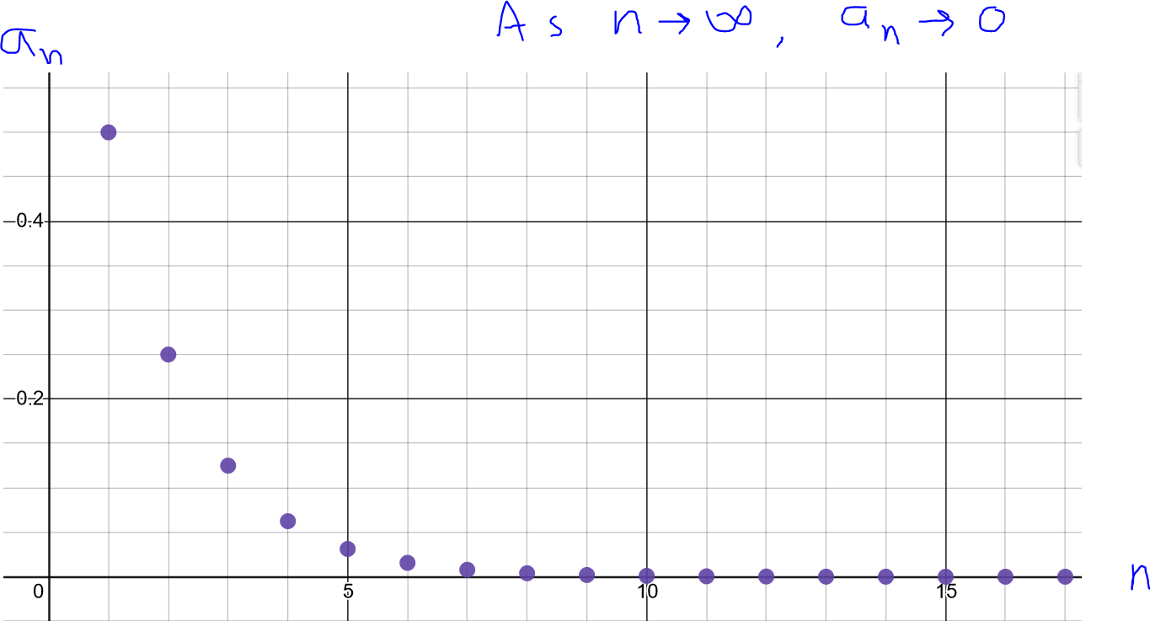

The infinite sum formula comes from the partial sum formula:

*Example #2* – Find the Infinite Sum

a) $1/2+1/4+1/8+1/{16}+…$

This is the series described on the previous page. Through intuition and context, we know it must add to ONE.

Since the common ratio is between $-1$ and $1$, we can find the infinite sum. Specifically, the first term is $a_{1}=1/2$ and the common ratio is $r=$

b) $1+2/3+4/9+8/{27}+…$

The first term is $a_{1}=1$ and the common ratio is $r=$ since the common ratio is between $-1$ and $1$:

c) $2-2/7+2/{49}-2/{343}+…$

The first term is $a_{1}=2$ and the common ratio is $r=$ since $r$ is between $-1$ and $1$:

This series alternates between positive and negative, but eventually the terms gravitate to zero as $n$ gets larger. This allows us to effectively “truncate” the terms and come up with finite sum to an infinite series.

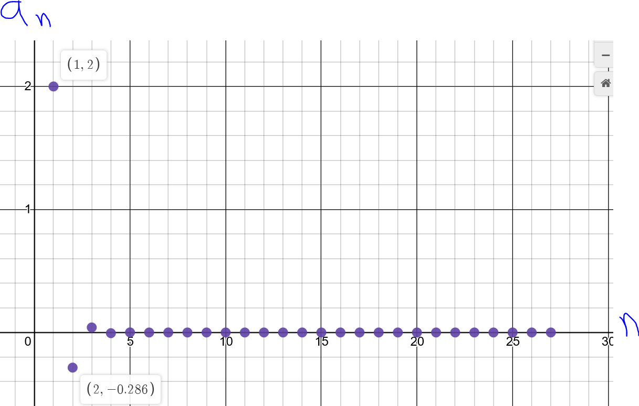

# **Topic #3: Applications of Geometric Series**

*Example #1* – Applications of Geometric Series/Partial Sum

Suppose a person deposits $1 into bank the first day of the month, $2 the second day, $4 the third, and so forth in a doubling pattern. Assume that the account does not earn interest.

a) How much money will be deposited on the 15th day?

The first few terms establish a geometric sequence:

$$1, 2, 4, 8,…$$

where $a_{1}=1$ and $r=$

When $n=15$, the 15th term of the sequence is:

b) What is the total amount in the account on the 15th day?

This is asking for a sum of the first 15 terms:

*Example #2* – Applications of Geometric Series/Partial Sum

A job pays a salary of $24,000 the first year. Each year after, the salary increases by 5% of the previous year’s salary.

a) What will be the salary on the 20th year?

Increasing by 5% suggests each year is 105% the previous, this establishes a geometric sequence:

$$24000, 24000(1.05), 24000{\left(1.05\right)}^{2}, 24000{\left(1.05\right)}^{3},…$$

where $a_{1}=24000$ and $r=1.05$

When $n=20$, the 20th term of the sequence is:

b) What are the total salary earnings over the 20-year period?

This is asking for a sum of the first 20 terms:

*Example #3* – Applications of Geometric Series/Infinite Sum

Suppose that a local government wants to stimulate the economy by giving each adult resident a $2000 stimulus check. The government expects that each person will spend 70% at local businesses, and that local businesses will spend 70% of that money to pay employees, who will spend 70% of their wages at local businesses, and so on. This is a principle in economics called the Multiplier Effect.

a) How much of the stimulus check is an adult resident expected to spend at local businesses?

70% of each stimulus check is expected to be spent at local businesses:

b) How much of the money earned from a stimulus check is each business expected to pay employees?

70% of the money spent at a local business is expected to go to employees:

c) How much of the wages earned from a stimulus check is each employee expected to spend on the local economy?

70% of the money that goes to employees is expected to be spent on local businesses:

d) What is the total amount of spending expected from a stimulus check?

The spending will continue in this pattern, which is a geometric sequence. The total spent is the geometric series:

$$1400+980+686+…$$

Theoretically the “trickle down” will continue indefinitely, giving an infinite series where $a_{1}=1400$ and $r=0.70$. Since the common ratio is between $-1$ and $1$, we can calculate the series:

This means that a $2000 stimulus check will contribute about ________________into the local economy, which is more than double the return on the initial investment.